1. CUSTOMERS TABLE

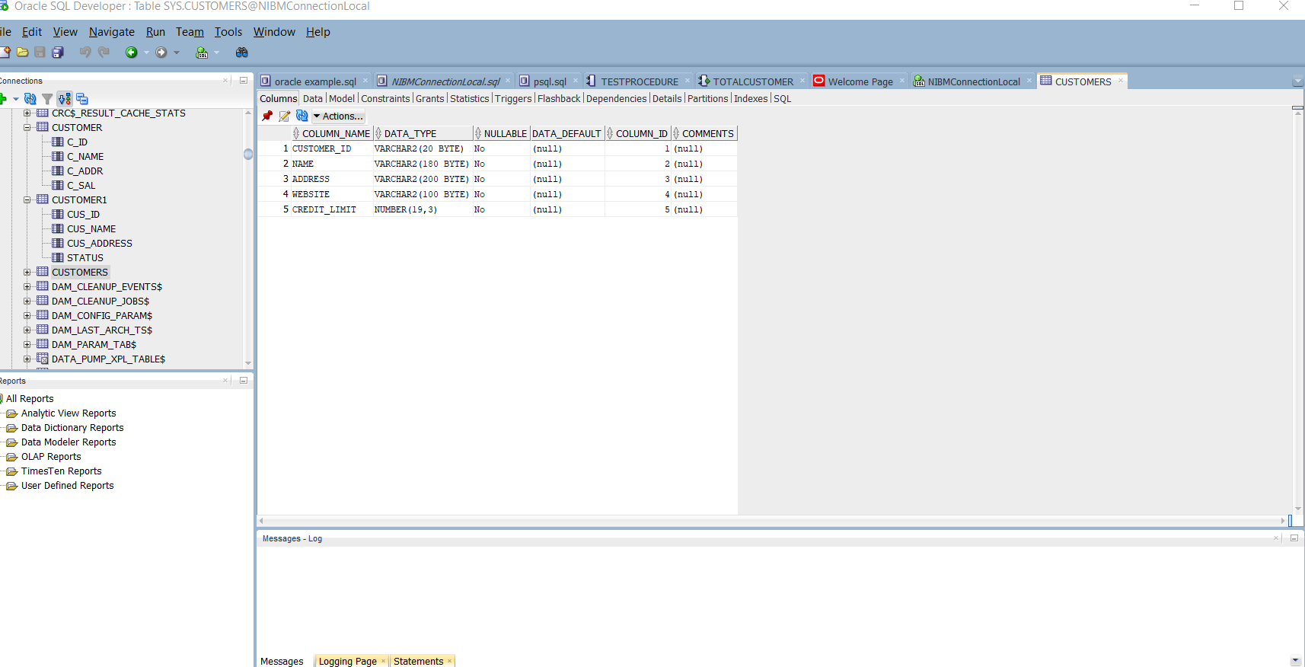

1. CONTACTS TABLE

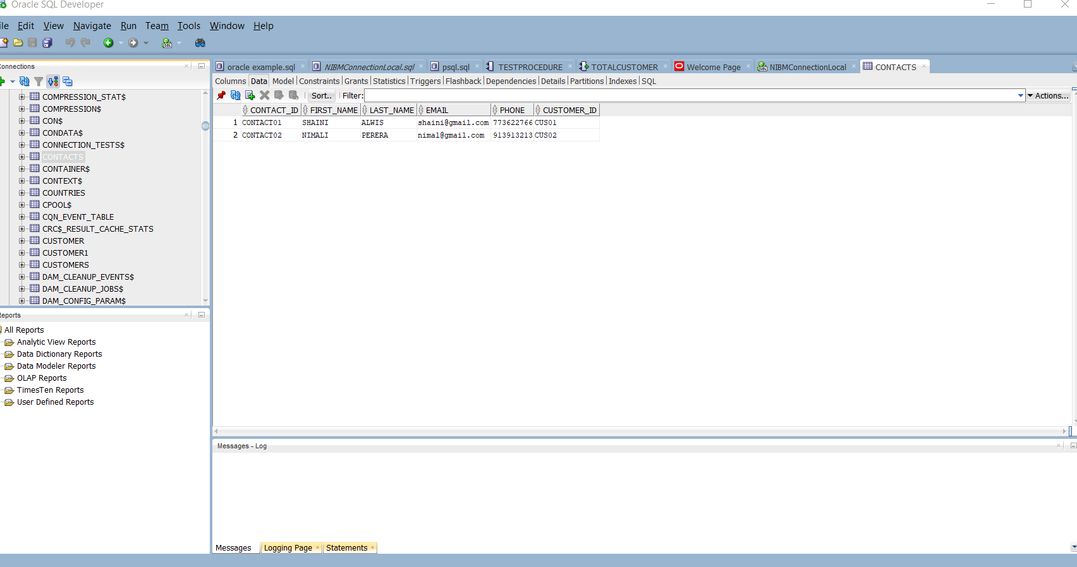

1. EMPLOYEES TABLE

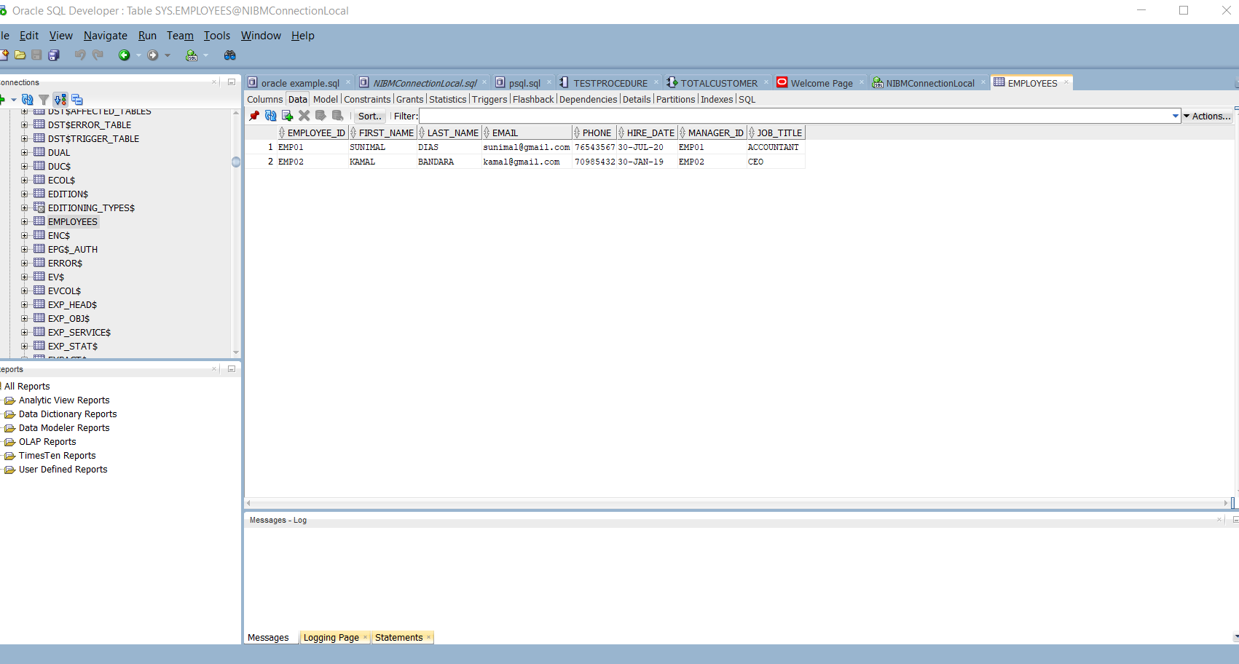

1. ORDERS

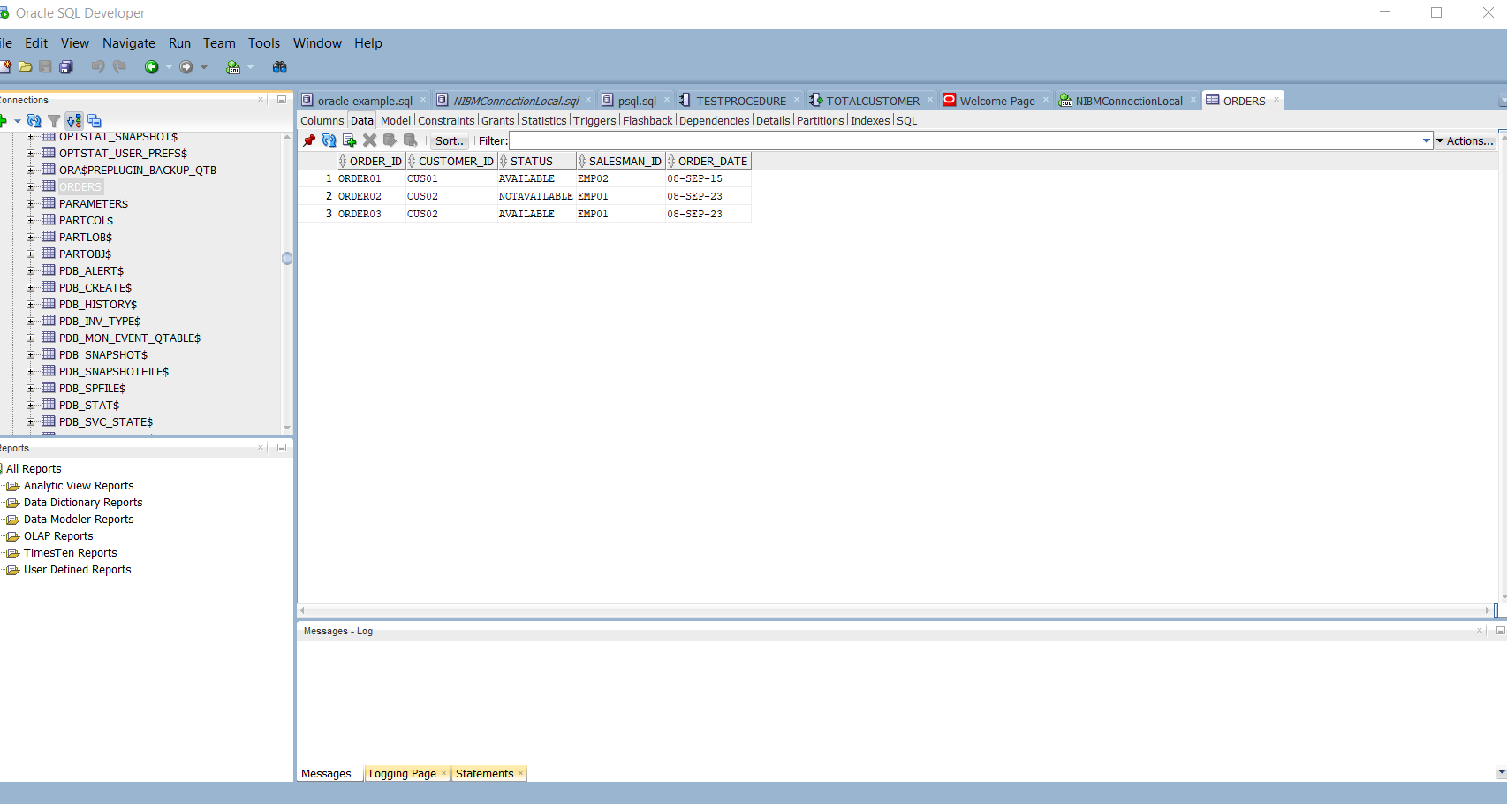

1. PRODUCT CATAGORIES

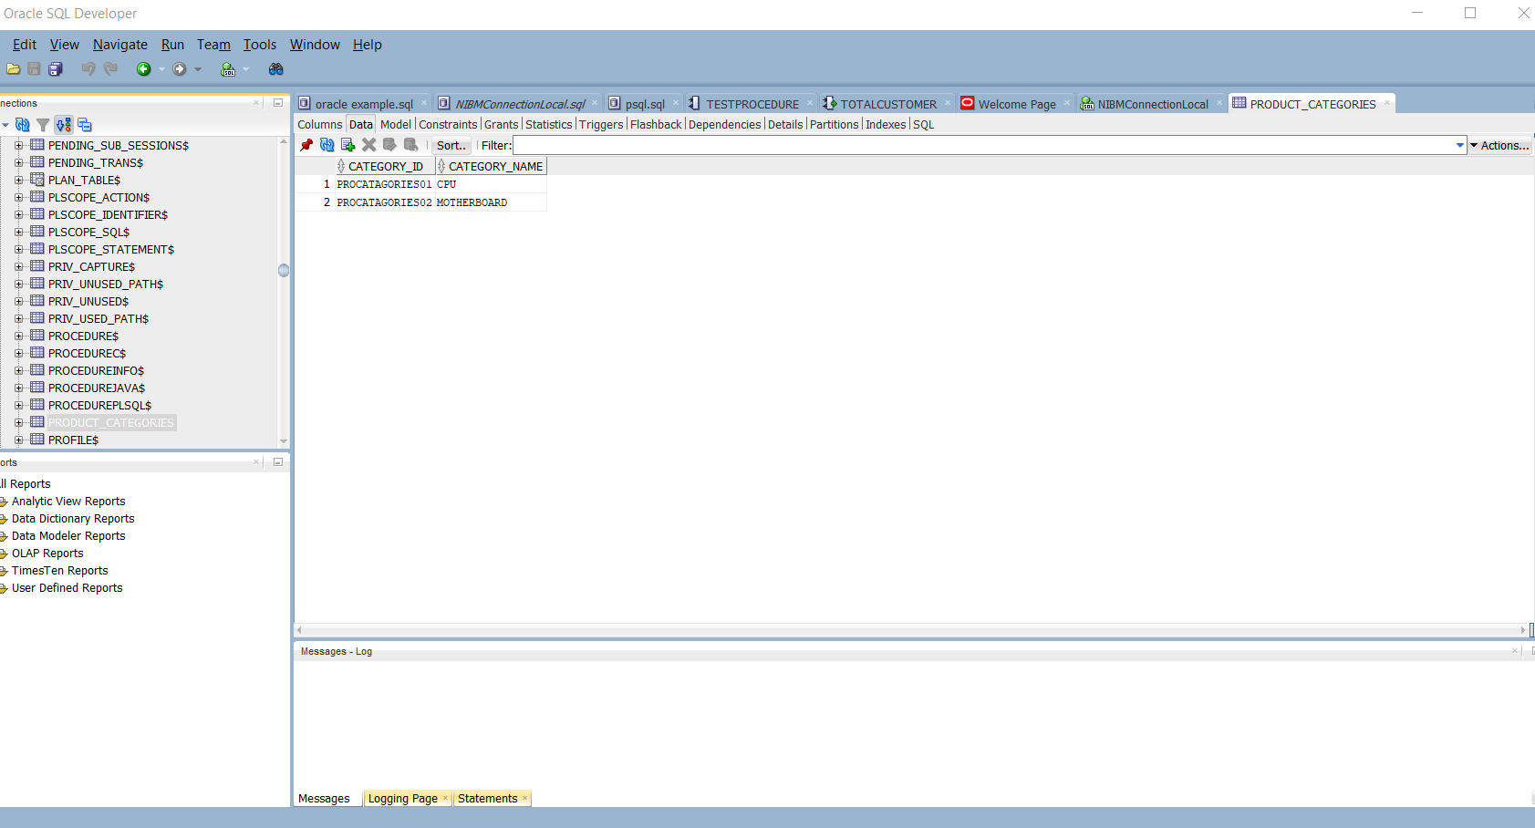

1. PRODUCTS

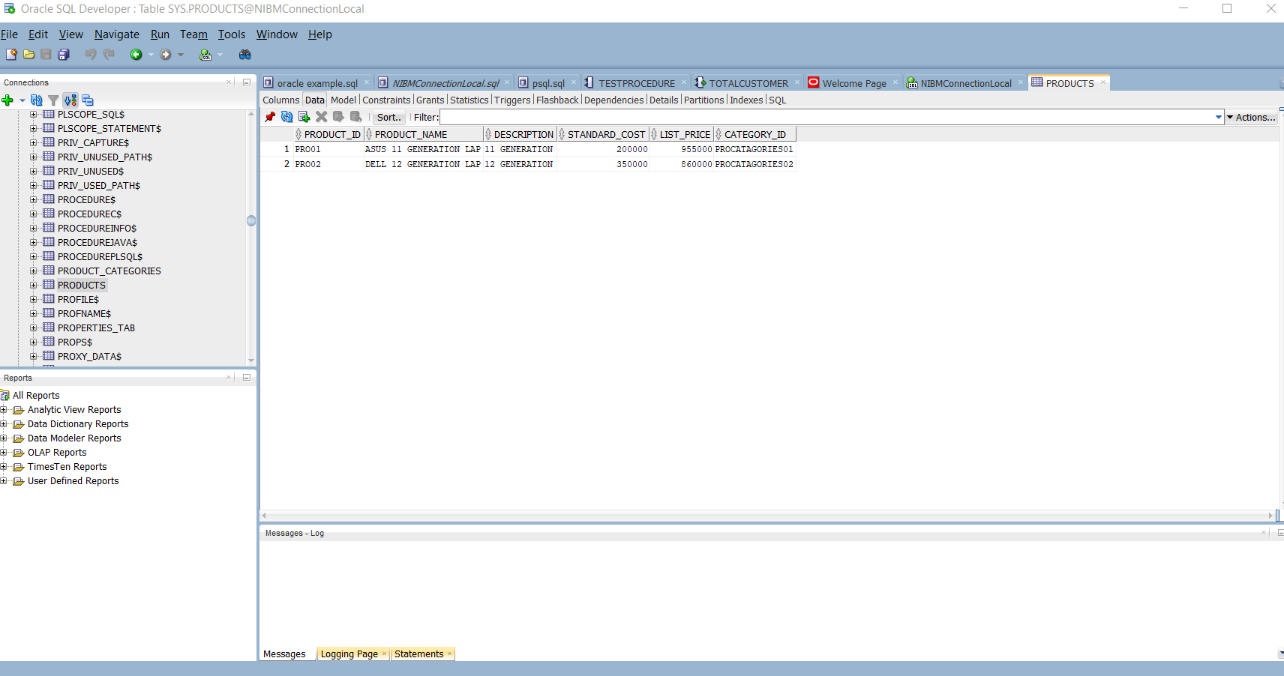

1. ORDER_ITEM

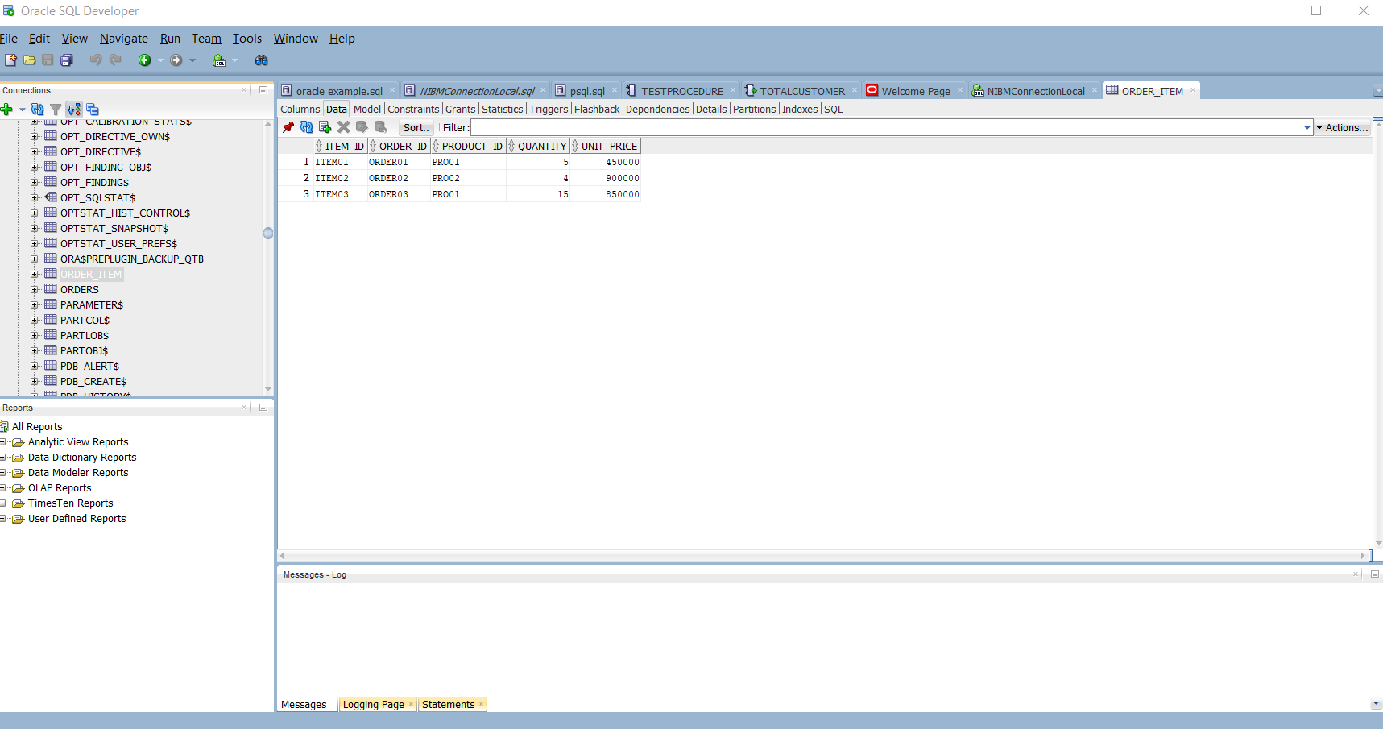

1. REGIONS TABLE

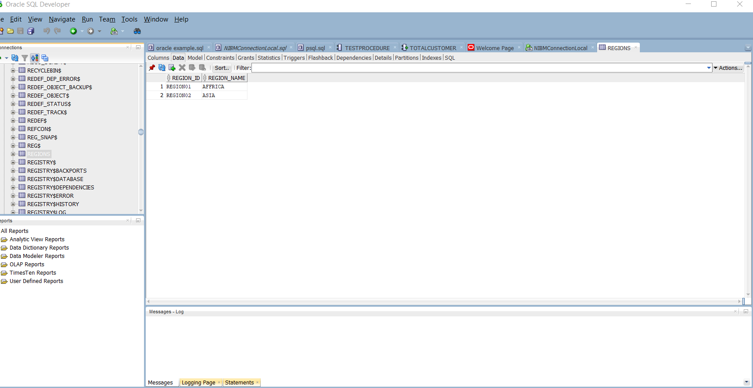

1. COUNTRIES1

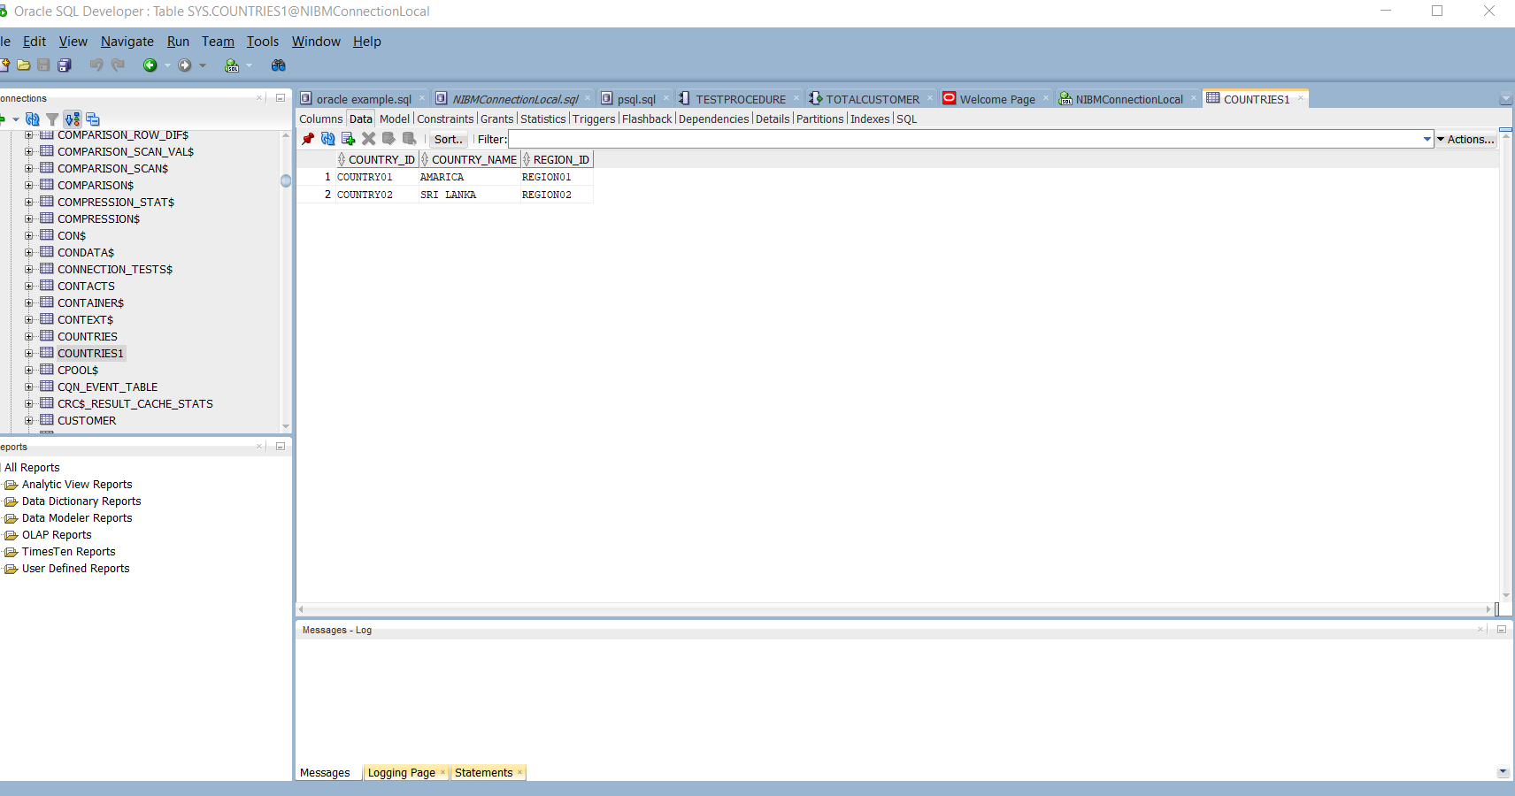

1. LOCATIONS

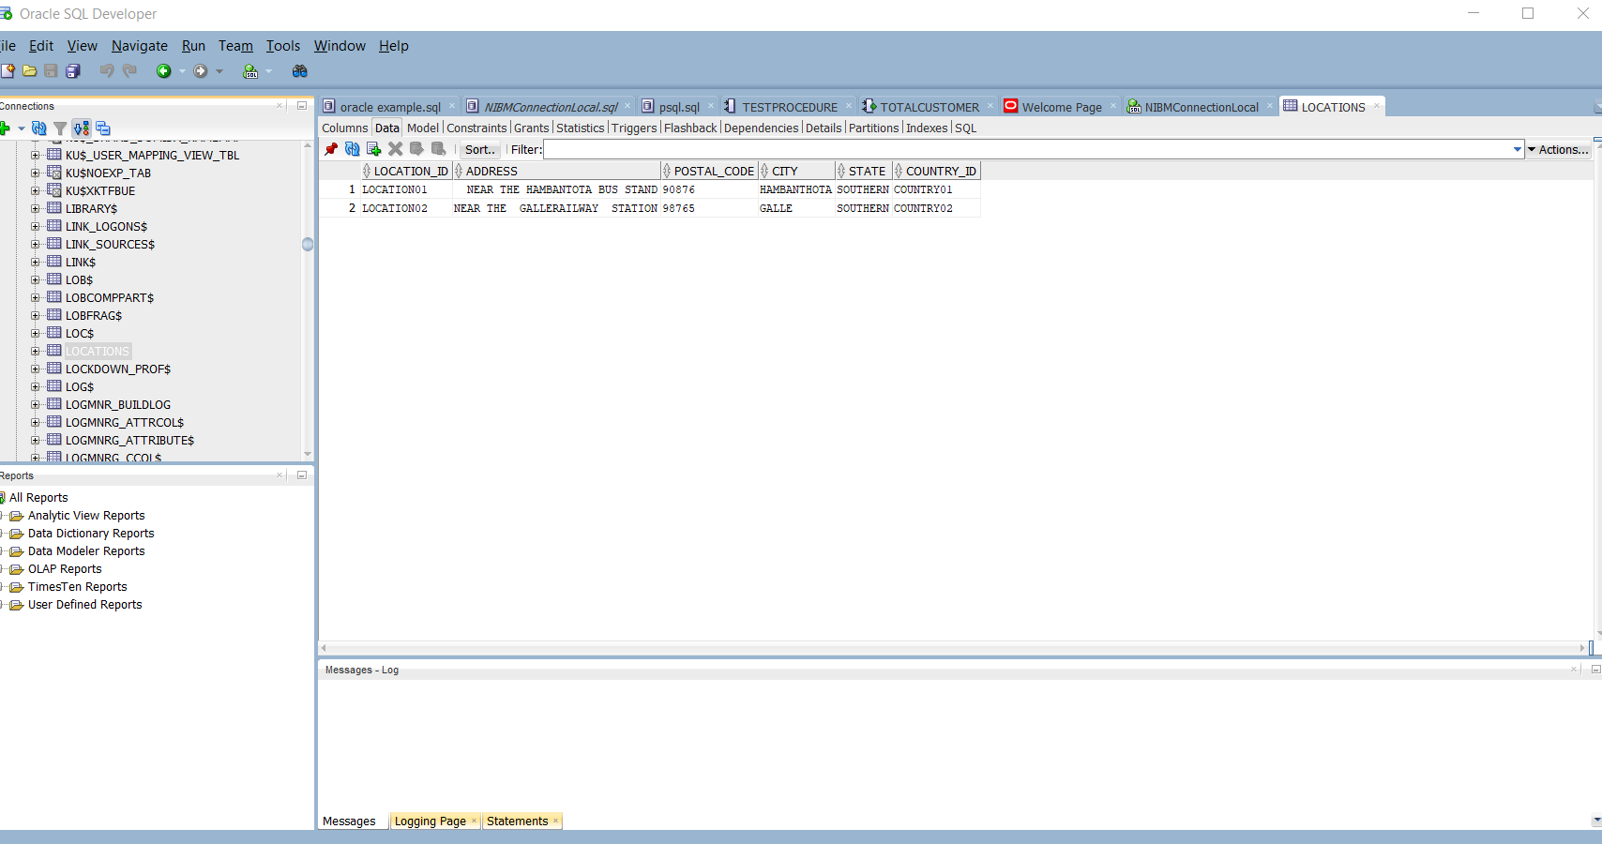

1. WAREHOUSES

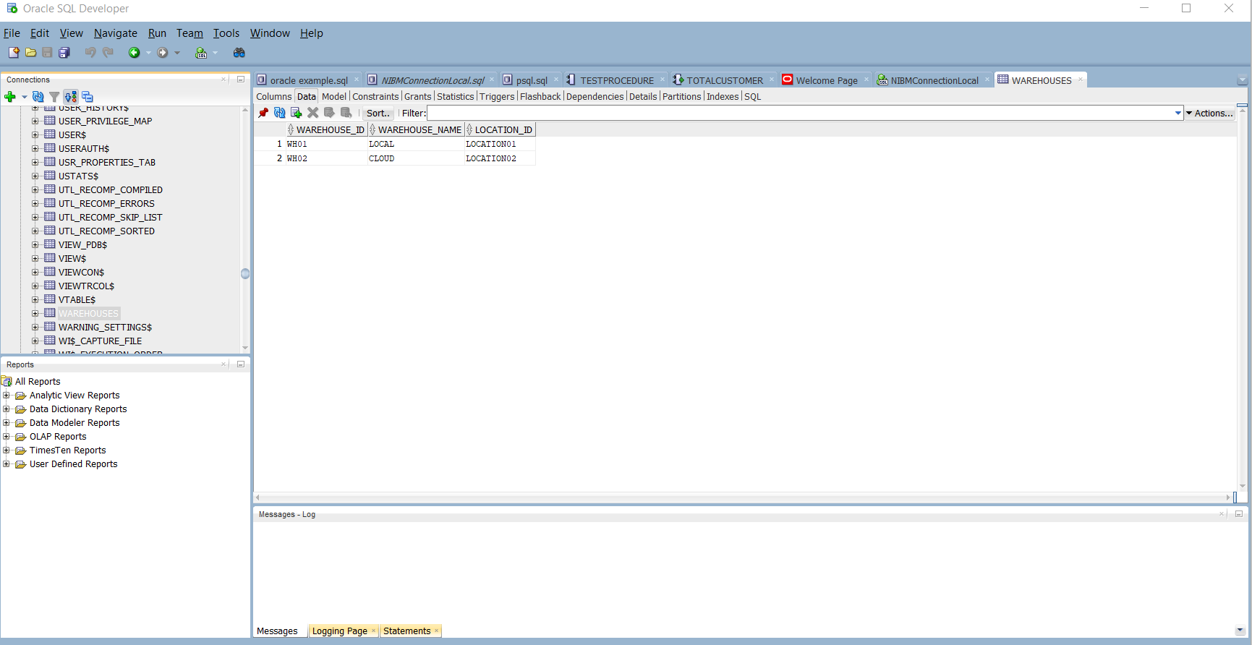

1. INVENTORIES

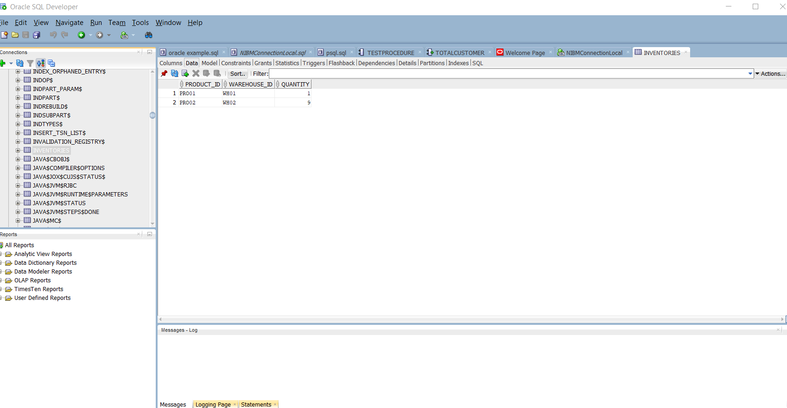

Q1

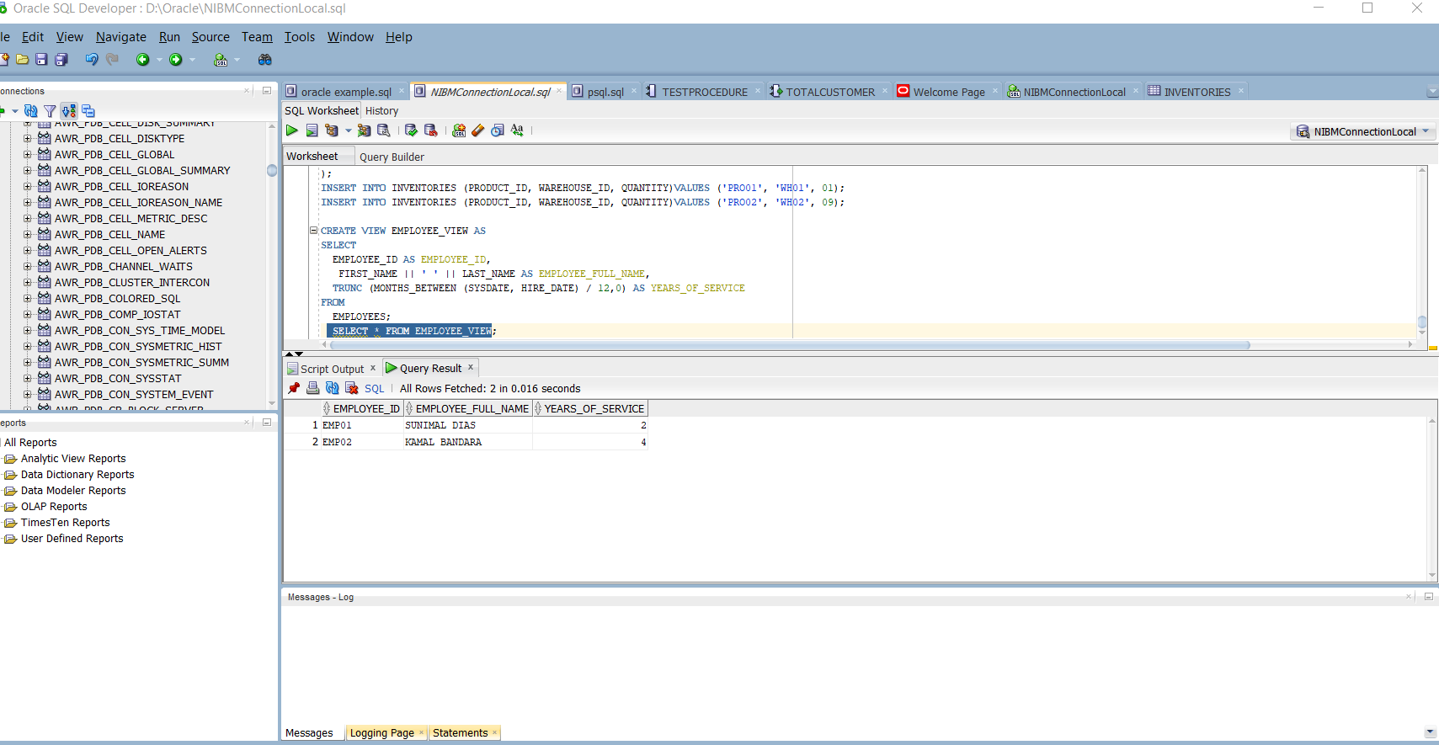

Q2.

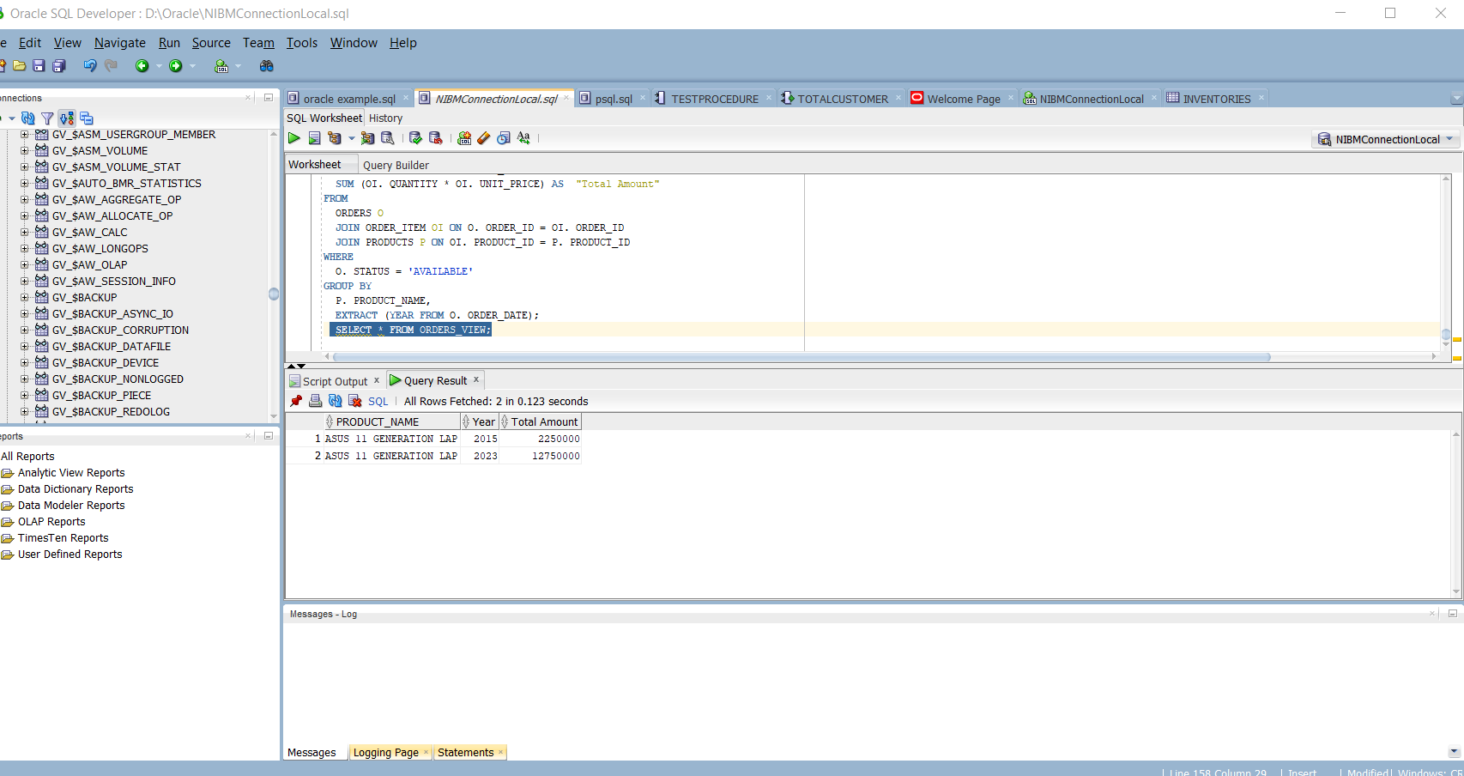

Q3

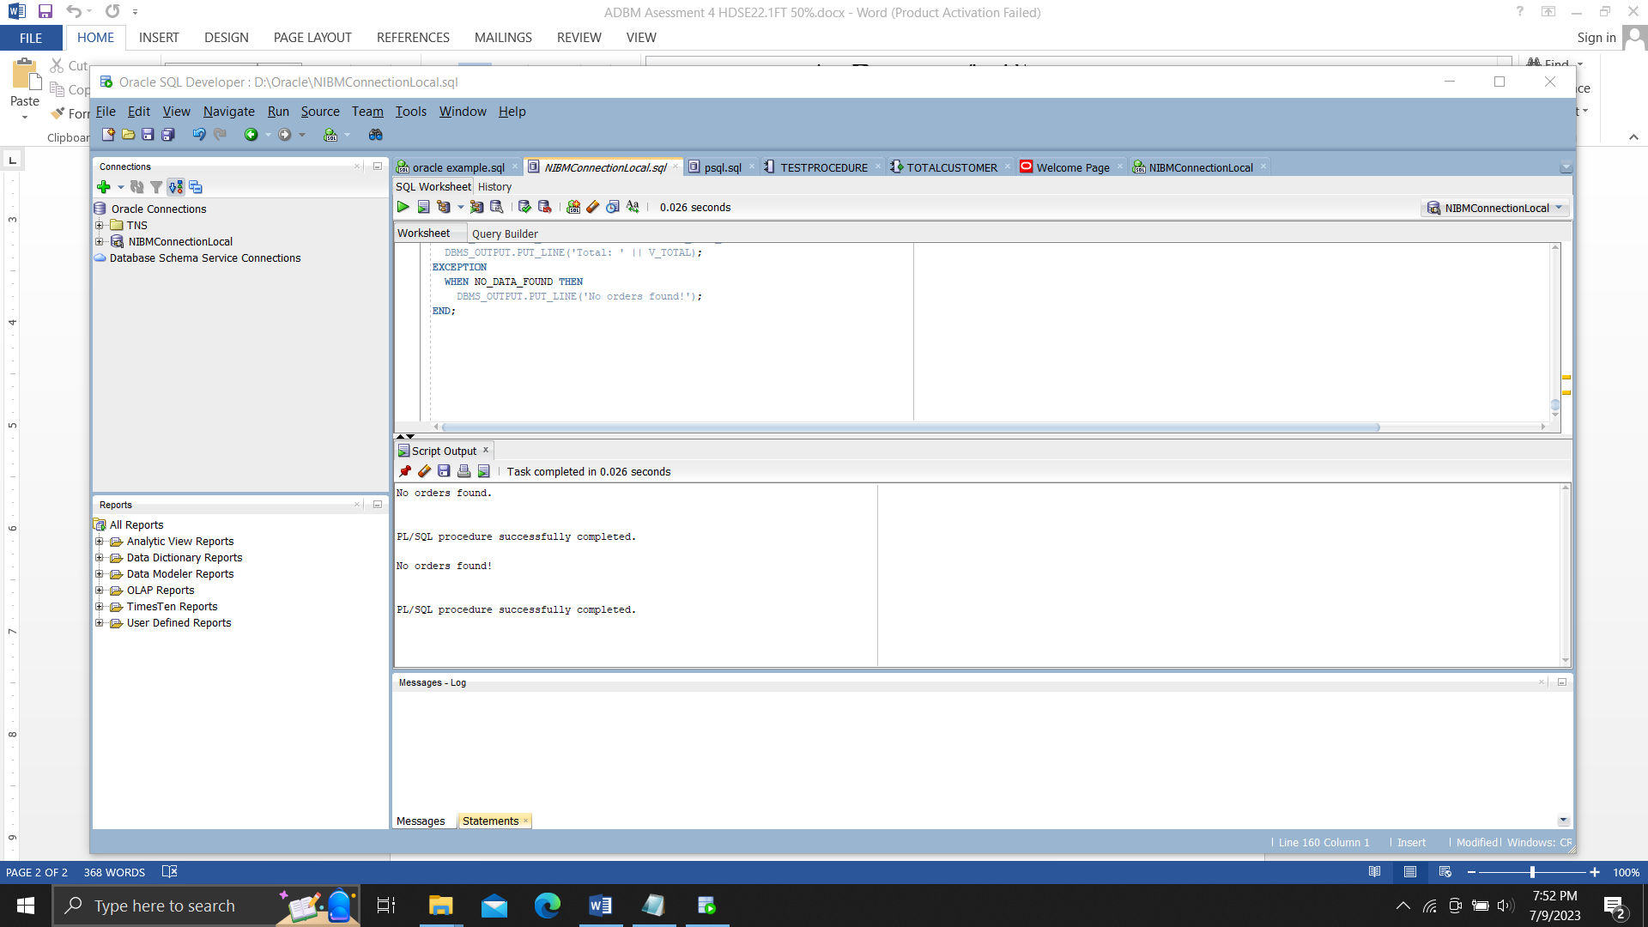

Q4

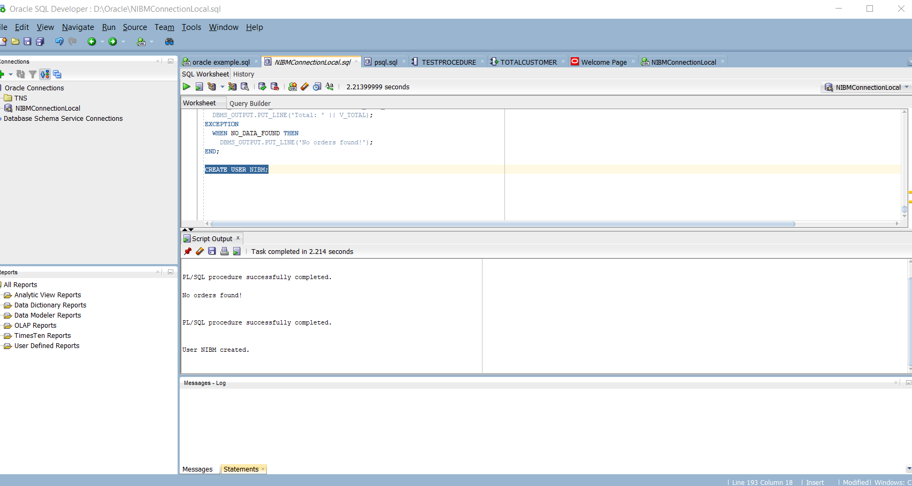

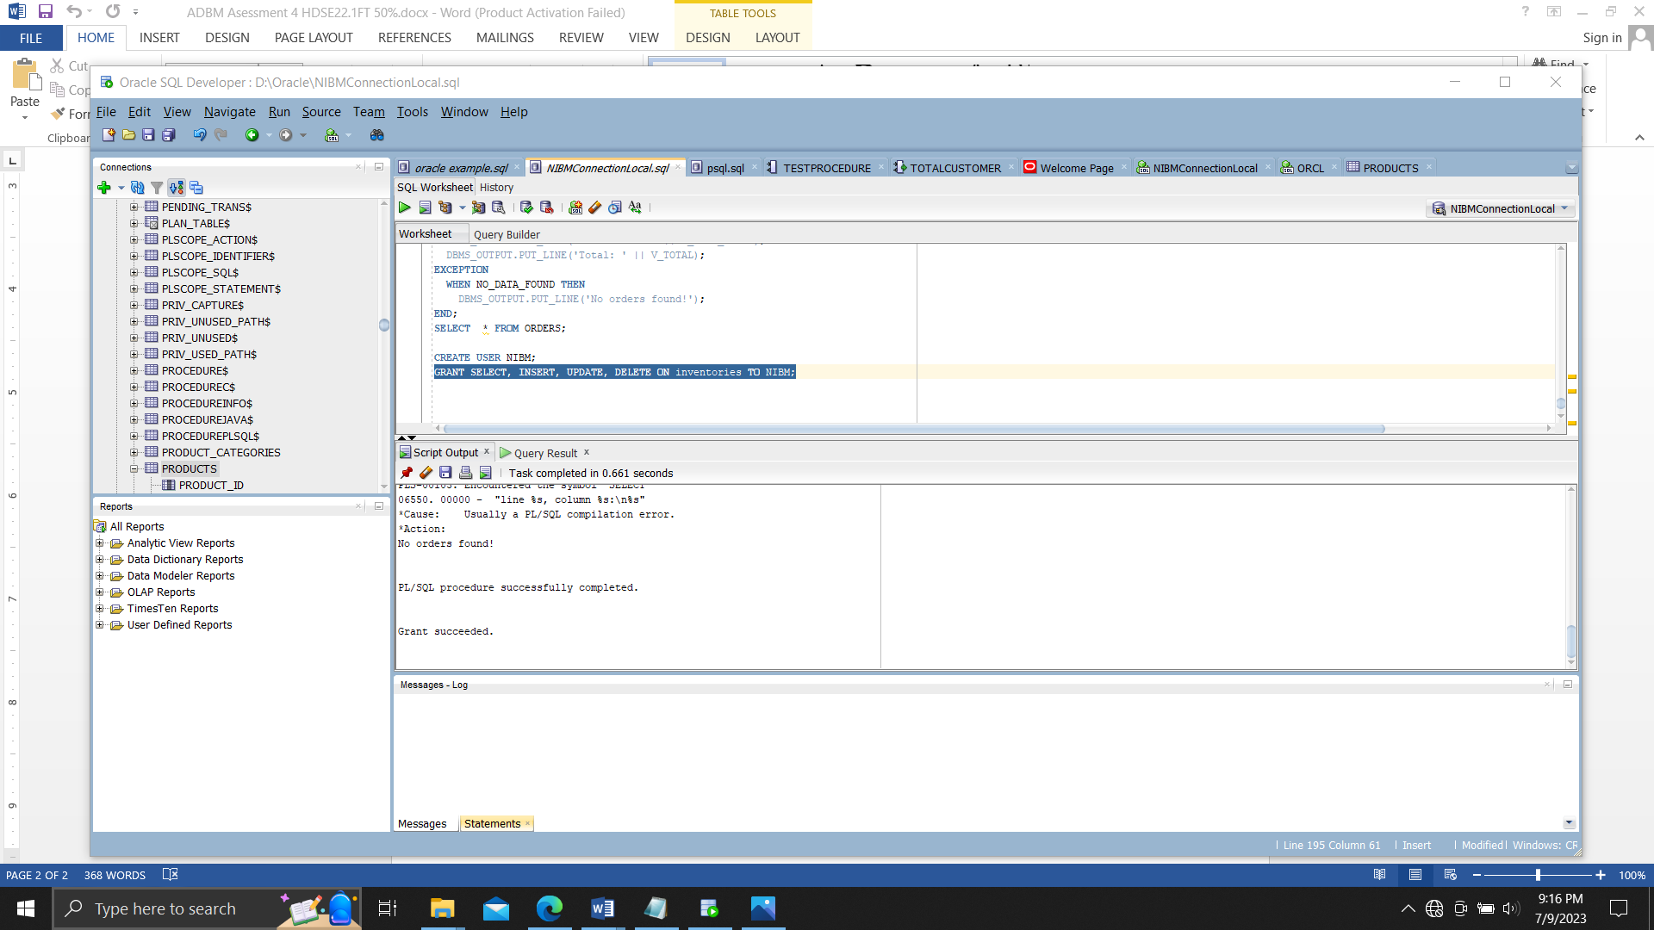

SET SERVEROUTPUT ON

CREATE TABLE CUSTOMERS(

CUSTOMER_ID VARCHAR (20) PRIMARY KEY NOT NULL,

NAME VARCHAR (180) NOT NULL,

ADDRESS VARCHAR (200) NOT NULL,

WEBSITE VARCHAR (100) NOT NULL,

CREDIT_LIMIT NUMBER (19,3) NOT NULL

);

INSERT INTO CUSTOMERS (CUSTOMER_ID, NAME, ADDRESS, WEBSITE, CREDIT_LIMIT) VALUES ('CUS01', 'THARU', 'MATARA', 'www.tharu@gmail.com', 300000.00);

INSERT INTO CUSTOMERS (CUSTOMER_ID, NAME, ADDRESS, WEBSITE, CREDIT_LIMIT) VALUES ('CUS02', 'NETHU', 'GALLE', 'www.nethu@gmail.com', 200000.00);

CREATE TABLE CONTACTS (

CONTACT_ID VARCHAR (60) PRIMARY KEY NOT NULL,

FIRST_NAME VARCHAR (200) NOT NULL,

LAST_NAME VARCHAR (200) NOT NULL,

EMAIL VARCHAR (100) NOT NULL,

PHONE INT NOT NULL,

CUSTOMER_ID VARCHAR (20) NOT NULL,

FOREIGN KEY(CUSTOMER_ID) REFERENCES CUSTOMERS(CUSTOMER_ID)

);

INSERT INTO CONTACTS (CONTACT_ID, FIRST_NAME, LAST_NAME, EMAIL, PHONE, CUSTOMER_ID) VALUES ('CONTACT01', 'SHAINI', 'ALWIS', 'shaini@gmail.com', 0773622766, 'CUS01');

INSERT INTO CONTACTS (CONTACT_ID, FIRST_NAME, LAST_NAME, EMAIL, PHONE, CUSTOMER_ID) VALUES ('CONTACT02', 'NIMALI', 'PERERA', 'nimal@gmail.com', 0913913213, 'CUS02');

CREATE TABLE EMPLOYEES (

EMPLOYEE_ID VARCHAR (30) PRIMARY KEY NOT NULL,

FIRST_NAME VARCHAR (200) NOT NULL,

LAST_NAME VARCHAR (200) NOT NULL,

EMAIL VARCHAR (100) NOT NULL,

PHONE INT NOT NULL,

HIRE_DATE DATE NOT NULL,

MANAGER_ID VARCHAR (20) NOT NULL,

JOB_TITLE VARCHAR (40) NOT NULL,

FOREIGN KEY(MANAGER_ID) REFERENCES EMPLOYEES(EMPLOYEE_ID)

);

INSERT INTO EMPLOYEES (EMPLOYEE_ID, FIRST_NAME, LAST_NAME, EMAIL, PHONE, HIRE_DATE, MANAGER_ID, JOB_TITLE) VALUES ('EMP01', 'SUNIMAL', 'DIAS', 'sunimal@gmail.com', 076543567, DATE '2020-07-20', 'EMP01', 'ACCOUNTANT');

INSERT INTO EMPLOYEES (EMPLOYEE_ID, FIRST_NAME, LAST_NAME, EMAIL, PHONE, HIRE_DATE, MANAGER_ID, JOB_TITLE) VALUES ('EMP02', 'KAMAL', 'BANDARA', 'kamal@gmail.com', 070985432, DATE '2019-01-30', 'EMP02', 'CEO');

CREATE TABLE ORDERS (

ORDER_ID VARCHAR (60) PRIMARY KEY NOT NULL,

CUSTOMER_ID VARCHAR (20) NOT NULL,

STATUS VARCHAR (50) NOT NULL,

SALESMAN_ID VARCHAR (40) NOT NULL,

ORDER_DATE DATE NOT NULL,

FOREIGN KEY(CUSTOMER_ID) REFERENCES CUSTOMERS(CUSTOMER_ID),

FOREIGN KEY(SALESMAN_ID) REFERENCES EMPLOYEES(EMPLOYEE_ID)

);

INSERT INTO ORDERS (ORDER_ID, CUSTOMER_ID, STATUS, SALESMAN_ID, ORDER_DATE)VALUES ('ORDER01', 'CUS01', 'AVAILABLE', 'EMP02', DATE '2015-09-08');

INSERT INTO ORDERS (ORDER_ID, CUSTOMER_ID, STATUS, SALESMAN_ID, ORDER_DATE)VALUES ('ORDER02', 'CUS02', 'NOTAVAILABLE', 'EMP01', DATE '2023-09-08');

INSERT INTO ORDERS (ORDER_ID, CUSTOMER_ID, STATUS, SALESMAN_ID, ORDER_DATE)VALUES ('ORDER03', 'CUS02', 'AVAILABLE', 'EMP01', DATE '2023-09-08');

CREATE TABLE PRODUCT_CATEGORIES (

CATEGORY_ID VARCHAR (60) NOT NULL PRIMARY KEY,

CATEGORY_NAME VARCHAR (12) NOT NULL

);

INSERT INTO PRODUCT_CATEGORIES (CATEGORY_ID, CATEGORY_NAME)VALUES ('PROCATAGORIES01', 'CPU');

INSERT INTO PRODUCT_CATEGORIES (CATEGORY_ID, CATEGORY_NAME)VALUES ('PROCATAGORIES02', 'MOTHERBOARD');

CREATE TABLE PRODUCTS(

PRODUCT_ID VARCHAR (20) PRIMARY KEY NOT NULL,

PRODUCT_NAME VARCHAR (70) NOT NULL,

DESCRIPTION VARCHAR (70) NOT NULL,

STANDARD_COST NUMBER(38,0) NOT NULL,

LIST_PRICE NUMBER(38,0) NOT NULL,

CATEGORY_ID VARCHAR2(20) NOT NULL,

FOREIGN KEY(CATEGORY_ID) REFERENCES PRODUCT_CATEGORIES(CATEGORY_ID)

);

INSERT INTO PRODUCTS (PRODUCT_ID, PRODUCT_NAME, DESCRIPTION, STANDARD_COST, LIST_PRICE, CATEGORY_ID) VALUES ('PRO01', 'ASUS 11 GENERATION LAP', '11 GENERATION', 200000.00, 955000.00,'PROCATAGORIES01' );

INSERT INTO PRODUCTS (PRODUCT_ID, PRODUCT_NAME, DESCRIPTION, STANDARD_COST, LIST_PRICE, CATEGORY_ID) VALUES ('PRO02', 'DELL 12 GENERATION LAP', '12 GENERATION', 350000.00, 860000.00, 'PROCATAGORIES02');

CREATE TABLE ORDER_ITEM (

ITEM_ID VARCHAR (20) NOT NULL PRIMARY KEY,

ORDER_ID VARCHAR (60) NOT NULL ,

PRODUCT_ID VARCHAR (20) NOT NULL,

QUANTITY INT NOT NULL,

UNIT_PRICE NUMBER (10, 2) NOT NULL,

FOREIGN KEY(ORDER_ID) REFERENCES ORDERS(ORDER_ID),

FOREIGN KEY(PRODUCT_ID) REFERENCES PRODUCTS(PRODUCT_ID)

);

INSERT INTO ORDER_ITEM (ITEM_ID, ORDER_ID, PRODUCT_ID, QUANTITY, UNIT_PRICE) VALUES ('ITEM01', 'ORDER01', 'PRO01', 5, 450000.00);

INSERT INTO ORDER_ITEM (ITEM_ID, ORDER_ID, PRODUCT_ID, QUANTITY, UNIT_PRICE) VALUES ('ITEM02', 'ORDER02', 'PRO02', 4, 900000.00);

INSERT INTO ORDER_ITEM (ITEM_ID, ORDER_ID, PRODUCT_ID, QUANTITY, UNIT_PRICE) VALUES ('ITEM03', 'ORDER03', 'PRO01', 15, 850000.00);

CREATE TABLE REGIONS (

REGION_ID VARCHAR (20) PRIMARY KEY NOT NULL,

REGION_NAME VARCHAR (30) NOT NULL

);

INSERT INTO REGIONS (REGION_ID, REGION_NAME)VALUES ('REGION01', 'AFFRICA ');

INSERT INTO REGIONS (REGION_ID, REGION_NAME)VALUES ('REGION02', 'ASIA');

CREATE TABLE COUNTRIES1 (

COUNTRY_ID VARCHAR (20) PRIMARY KEY NOT NULL,

COUNTRY_NAME VARCHAR (30) NOT NULL,

REGION_ID VARCHAR (20) NOT NULL,

FOREIGN KEY(REGION_ID) REFERENCES REGIONS(REGION_ID)

);

INSERT INTO COUNTRIES1 (COUNTRY_ID, COUNTRY_NAME, REGION_ID)VALUES ('COUNTRY01', 'AMARICA', 'REGION01');

INSERT INTO COUNTRIES1 (COUNTRY_ID, COUNTRY_NAME, REGION_ID)VALUES ('COUNTRY02', 'SRI LANKA', 'REGION02');

CREATE TABLE LOCATIONS (

LOCATION_ID VARCHAR (20) PRIMARY KEY NOT NULL,

ADDRESS VARCHAR (150) NOT NULL,

POSTAL_CODE VARCHAR (15) NOT NULL,

CITY VARCHAR (20) NOT NULL,

STATE VARCHAR (20) NOT NULL,

COUNTRY_ID VARCHAR (20) NOT NULL,

FOREIGN KEY(COUNTRY_ID) REFERENCES COUNTRIES1(COUNTRY_ID)

);

INSERT INTO LOCATIONS (LOCATION_ID, ADDRESS, POSTAL_CODE, CITY, STATE, COUNTRY_ID) VALUES ('LOCATION01', ' NEAR THE HAMBANTOTA BUS STAND', '90876', 'HAMBANTHOTA', 'SOUTHERN', 'COUNTRY01');

INSERT INTO LOCATIONS (LOCATION_ID, ADDRESS, POSTAL_CODE, CITY, STATE, COUNTRY_ID) VALUES ('LOCATION02', 'NEAR THE GALLERAILWAY STATION', '98765', 'GALLE', 'SOUTHERN', 'COUNTRY02');

CREATE TABLE WAREHOUSES (

WAREHOUSE_ID VARCHAR (20) PRIMARY KEY NOT NULL,

WAREHOUSE_NAME VARCHAR (20) NOT NULL,

LOCATION_ID VARCHAR (20) NOT NULL,

FOREIGN KEY(LOCATION_ID) REFERENCES LOCATIONS(LOCATION_ID)

);

INSERT INTO WAREHOUSES (WAREHOUSE_ID, WAREHOUSE_NAME, LOCATION_ID)VALUES ('WH01', 'LOCAL ', 'LOCATION01');

INSERT INTO WAREHOUSES (WAREHOUSE_ID, WAREHOUSE_NAME, LOCATION_ID)VALUES ('WH02', 'CLOUD', 'LOCATION02');

CREATE TABLE INVENTORIES (

PRODUCT_ID VARCHAR (20) NOT NULL,

WAREHOUSE_ID VARCHAR (20) NOT NULL,

QUANTITY INT NOT NULL,

PRIMARY KEY(PRODUCT_ID,WAREHOUSE_ID),

FOREIGN KEY(PRODUCT_ID) REFERENCES PRODUCTS(PRODUCT_ID),

FOREIGN KEY(WAREHOUSE_ID) REFERENCES WAREHOUSES(WAREHOUSE_ID)

);

INSERT INTO INVENTORIES (PRODUCT_ID, WAREHOUSE_ID, QUANTITY)VALUES ('PRO01', 'WH01', 01);

INSERT INTO INVENTORIES (PRODUCT_ID, WAREHOUSE_ID, QUANTITY)VALUES ('PRO02', 'WH02', 09);

CREATE VIEW EMPLOYEE_VIEW AS

SELECT

EMPLOYEE_ID AS EMPLOYEE_ID,

FIRST_NAME || ' ' || LAST_NAME AS EMPLOYEE_FULL_NAME,

TRUNC (MONTHS_BETWEEN (SYSDATE, HIRE_DATE) / 12,0) AS YEARS_OF_SERVICE

FROM

EMPLOYEES;

SELECT * FROM EMPLOYEE_VIEW;

CREATE VIEW ORDERS_VIEW AS

SELECT

P. PRODUCT_NAME,

EXTRACT (YEAR FROM O. ORDER_DATE) AS "Year",

SUM (OI. QUANTITY * OI. UNIT_PRICE) AS "Total Amount"

FROM

ORDERS O

JOIN ORDER_ITEM OI ON O. ORDER_ID = OI. ORDER_ID

JOIN PRODUCTS P ON OI. PRODUCT_ID = P. PRODUCT_ID

WHERE

O. STATUS = 'AVAILABLE'

GROUP BY

P. PRODUCT_NAME,

EXTRACT (YEAR FROM O. ORDER_DATE);

SELECT * FROM ORDERS_VIEW;

DECLARE

V_ORDER_ID VARCHAR2(20);

V_ITEM_COUNT INT;

V_TOTAL NUMBER(10, 2);

BEGIN

SELECT

O.ORDER_ID,

COUNT(OI.ITEM_ID) AS "Item Count",

SUM(OI.QUANTITY * OI.UNIT_PRICE) AS "Total"

INTO

V_ORDER_ID,

V_ITEM_COUNT,

V_TOTAL

FROM

ORDERS O

JOIN ORDER_ITEM OI ON O.ORDER_ID = OI.ORDER_ID

GROUP BY

O.ORDER_ID

HAVING

SUM(OI.QUANTITY * OI.UNIT_PRICE) > 500000

AND COUNT(OI.ITEM_ID) BETWEEN 10 AND 12

ORDER BY

"Total" DESC, "Item Count";

DBMS_OUTPUT.PUT_LINE('Order ID: ' || V_ORDER_ID);

DBMS_OUTPUT.PUT_LINE('Item Count: ' || V_ITEM_COUNT);

DBMS_OUTPUT.PUT_LINE('Total: ' || V_TOTAL);

EXCEPTION

WHEN NO_DATA_FOUND THEN

DBMS_OUTPUT.PUT_LINE('No orders found!');

END;

CREATE USER NIBM;

GRANT SELECT, INSERT, UPDATE, DELETE ON inventories TO NIBM;